**Air Cargo Analysis**

**PROBLEM DESCRIPTION**

Air Cargo is an aviation company that provides air transportation services for passengers and freight. Air Cargo uses its aircraft to provide different services with the help of partnerships or alliances with other airlines. The company wants to prepare reports on regular passengers, busiest routes, ticket sales details, and other scenarios to improve the ease of travel and booking for customers.

TASKS TO BE PERFORMED:

1. Create an ER diagram for the given airlines database.
2. Write a query to create route_details table using suitable data types for the fields, such as route_id, flight_num, origin_airport, destination_airport, aircraft_id, and distance_miles. Implement the check constraint for the flight number and unique constraint for the route_id fields. Also, make sure that the distance miles field is greater than 0.
3. Write a query to display all the passengers (customers) who have travelled in routes 01 to 25. Take data from the passengers_on_flights table.
4. Write a query to identify the number of passengers and total revenue in business class from the ticket_details table.
5. Write a query to display the full name of the customer by extracting the first name and last name from the customer table.
6. Write a query to extract the customers who have registered and booked a ticket. Use data from the customer and ticket_details tables.
7. Write a query to identify the customer’s first name and last name based on their customer ID and brand (Emirates) from the ticket_details table.
8. Write a query to identify the customers who have travelled by *Economy Plus* class using Group By and Having clause on the passengers_on_flights table.
9. Write a query to identify whether the revenue has crossed 10000 using the IF clause on the ticket_details table.
10. Write a query to create and grant access to a new user to perform operations on a database.
11. Write a query to find the maximum ticket price for each class using window functions on the ticket_details table.
12. Write a query to extract the passengers whose route ID is 4 by improving the speed and performance of the passengers_on_flights table.
13. For the route ID 4, write a query to view the execution plan of the passengers_on_flights table.
14. Write a query to calculate the total price of all tickets booked by a customer across different aircraft IDs using rollup function.
15. Write a query to create a view with only business class customers along with the brand of airlines.
16. Write a query to create a stored procedure to get the details of all passengers flying between a range of routes defined in run time. Also, return an error message if the table doesn't exist.
17. Write a query to create a stored procedure that extracts all the details from the routes table where the travelled distance is more than 2000 miles.
18. Write a query to create a stored procedure that groups the distance travelled by each flight into three categories. The categories are, short distance travel (SDT) for >=0 AND <= 2000 miles, intermediate distance travel (IDT) for >2000 AND <=6500, and long-distance travel (LDT) for >6500.
19. Write a query to extract ticket purchase date, customer ID, class ID and specify if the complimentary services are provided for the specific class using a stored function in stored procedure on the ticket_details table.

Condition:

* If the class is *Business* and *Economy Plus,* then complimentary services are given as *Yes,*else it is *No*

    20. Write a query to extract the first record of the customer whose last name ends with Scott using a cursor from the customer table.

SOLUTION

CREATE DATABASE Air_Cargo_Analysis;

USE Air_Cargo_Analysis;

SET sql_mode=(SELECT REPLACE(@@sql_mode,'ONLY_FULL_GROUP_BY',''));

CREATE TABLE route_details (route_id int NOT NULL,

flight_num int NOT NULL,

origin_airport varchar(20),

destination_airport varchar(20),

aircraft_id varchar(10),

distance int NOT NULL,

UNIQUE(route_id), CHECK (distance>0));

SELECT*FROM passengers_on_flights

WHERE route_id BETWEEN 1 AND 25;

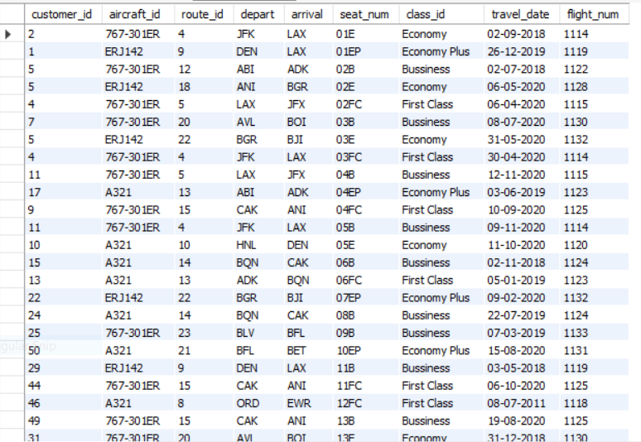

SELECT COUNT(class_id = 'Business') AS BUSINESS_CLASS_COUNT,

SUM(no_of_tickets*price_per_ticket) AS REVENUE_TOTAL FROM ticket_details

WHERE class_id = 'Bussiness';

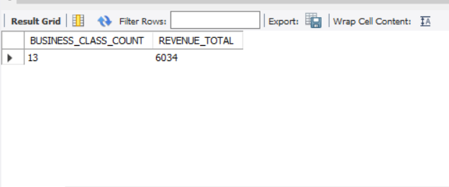

SELECT CONCAT(first_name, " ", last_name) AS FULL_NAME FROM customer;

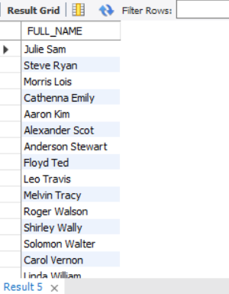

SELECT customer_id, CONCAT(first_name, " " , last_name) AS NAME,

COUNT(no_of_tickets) AS NO_OF_TICKETS

FROM customer

JOIN ticket_details USING (customer_id)

GROUP BY customer_id, NAME

ORDER BY NO_OF_TICKETS;

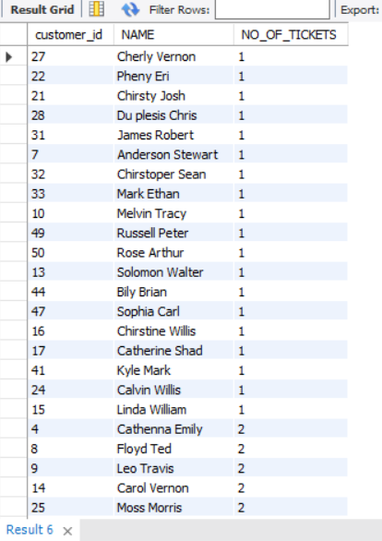

SELECT customer_id, first_name, last_name FROM customer

JOIN ticket_details USING(customer_id)

WHERE brand = 'Emirates';

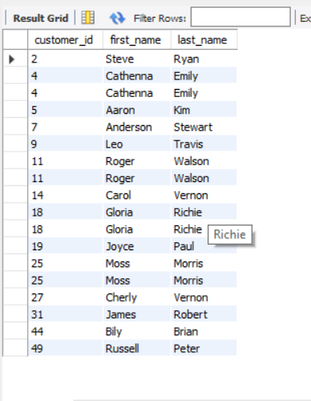

SELECT customer.customer_id, customer.first_name, customer.last_name, passengers_on_flights.class_id

FROM customer

JOIN passengers_on_flights ON customer.customer_id = passengers_on_flights.customer_id

WHERE passengers_on_flights.class_id = 'Economy Plus';

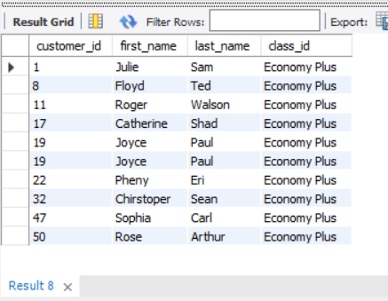

SELECT customer.customer_id, customer.first_name, customer.last_name, passengers_on_flights.class_id

FROM customer

JOIN passengers_on_flights ON customer.customer_id = passengers_on_flights.customer_id

GROUP BY customer_id

HAVING class_id = 'Economy Plus'

ORDER BY customer_id;

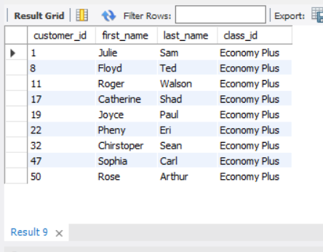

SELECT * , IF(SUM(no_of_tickets * Price_per_ticket)>10000,'Revenue Crossed 10000','Revenue Less Than 10000')

AS REVENUE_STATUS FROM ticket_details;

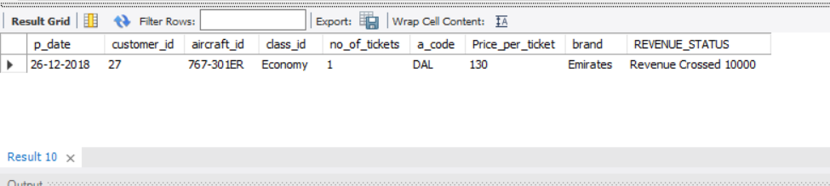

CREATE USER 'new_user'@'localhost' IDENTIFIED BY 'new_password';

GRANT ALL ON Air_Cargo_Analysis.* TO 'new_user'@'localhost';

SELECT customer_id,class_id,brand , MAX(Price_per_ticket) OVER (PARTITION BY class_id) AS max_price FROM ticket_details;

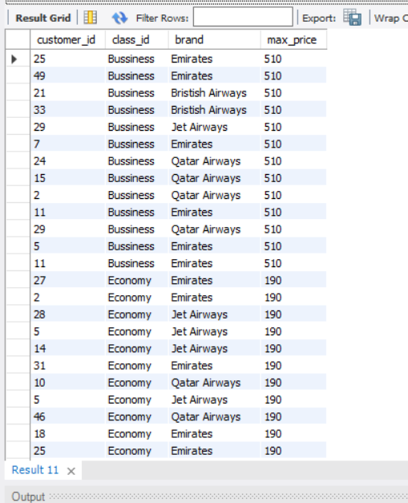

SELECT * FROM passengers_on_flights WHERE route_id = 4 ;

SELECT * FROM passengers_on_flights HAVING route_id = 4 ;

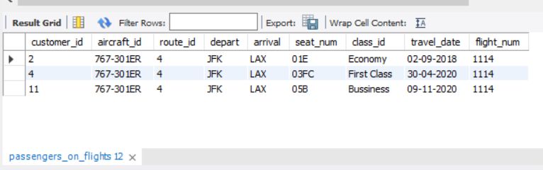

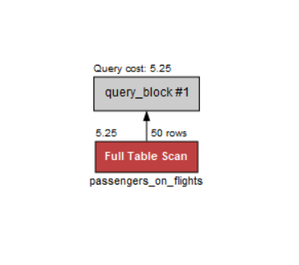

SELECT customer_id, aircraft_id , class_id , sum(no_of_tickets * Price_per_ticket)

AS total_price

FROM ticket_details

GROUP BY aircraft_id WITH ROLLUP ;

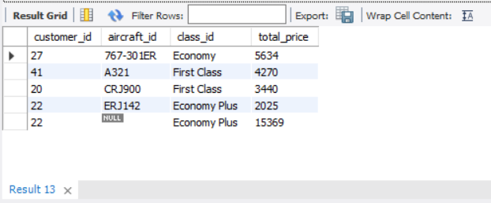

DROP VIEW business_class ;

CREATE VIEW business_class AS

SELECT customer_id, class_id, brand

FROM ticket_details

WHERE class_id = 'bussiness' ;

SELECT * FROM business_class ;

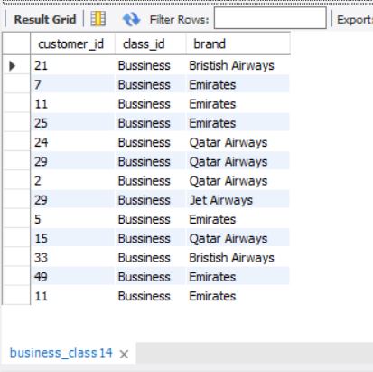

DROP PROCEDURE passenger_details;

DELIMITER &&

CREATE PROCEDURE passenger_details(route_id INT)

BEGIN

SELECT * FROM passengers_on_flights

WHERE route_id BETWEEN

1 AND 50 ORDER BY route_id ;

END &&

CALL passenger_details() ;

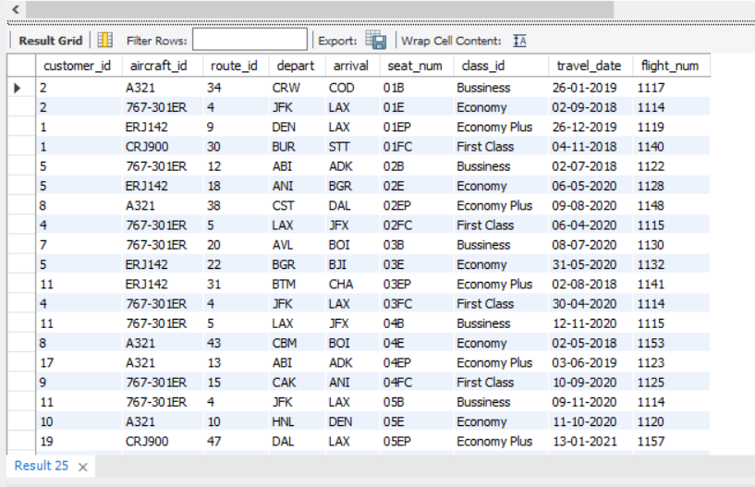

DROP PROCEDURE travelled_distance() IF EXIST ;

DELIMITER //

CREATE PROCEDURE travelled_distance()

BEGIN

SELECT * FROM routes WHERE distance_miles > 2000 ;

END //

CALL travelled_distance() ;

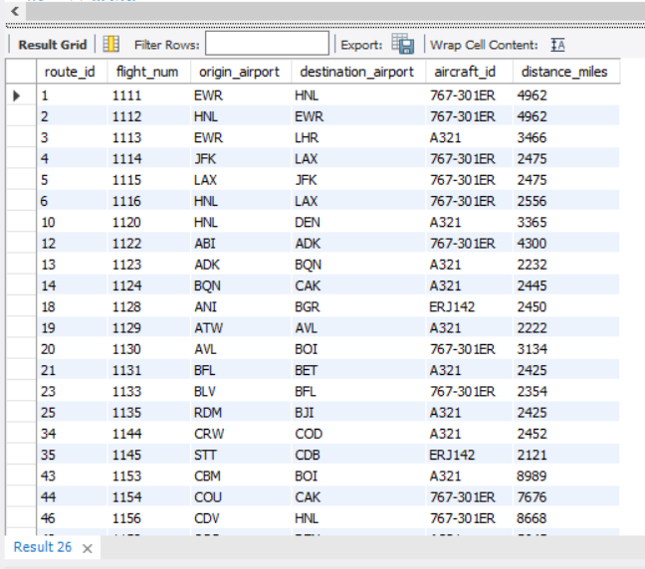

DROP PROCEDURE travel_category;

DELIMITER //

CREATE PROCEDURE travel_category(IN distance int , OUT category VARCHAR(40))

BEGIN

SELECT distance_miles INTO distance

FROM routes

WHERE routes.distance_miles = distance;

IF distance >= 0 AND distance <=2000 THEN

SET category = 'SHORT DISTANCE TRAVEL';

ELSEIF distance >= 2000 AND distance <=6500 THEN

SET category = 'INTERMEDIATE DISTANCE TRAVEL';

ELSEIF distance > 6000 THEN

SET category = 'LONG DISTANCE TRAVEL';

END IF ;

END //

CALL travel_category(1523 , @category) ;

SELECT @category;

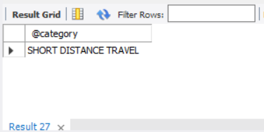

DROP FUNCTION IF EXISTS Complementary_Services

DELIMITER //

CREATE FUNCTION Complementary_Services(class_id VARCHAR(40))

RETURNS VARCHAR(10) DETERMINISTIC

BEGIN

DECLARE SERVICE VARCHAR(20);

IF class_id = 'Economy Plus' OR 'Business' THEN

SET SERVICE = 'YES';

ELSE SET SERVICE = 'NO';

END IF;

RETURN SERVICE;

END //

SELECT p_date,customer_id,class_id, Complementary_Services(class_id) AS SERVICE FROM ticket_details;

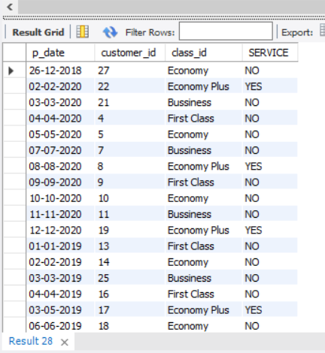

DROP PROCEDURE IF EXISTS First_Scott

DELIMITER //

CREATE PROCEDURE First_Scott()

BEGIN

DECLARE a VARCHAR(50);

DECLARE b VARCHAR(50);

DECLARE cursor_1 CURSOR FOR SELECT first_name, last_name FROM customer

WHERE last_name = 'Scott';

OPEN cursor_1;

REPEAT FETCH cursor_1 INTO a,b;

UNTIL b=0

END REPEAT;

SELECT a AS first_name , b as last_name;

CLOSE cursor_1;

END //

CALL First_Scott()



